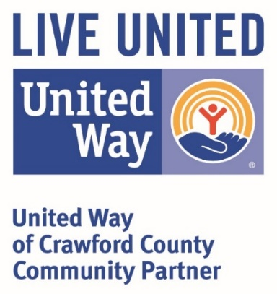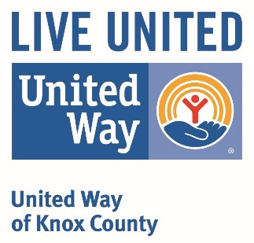

**Request to Apply for Funding**

**2021 Grant Year**

***Request needs to be filed by June 1, 2020***

***Return completed forms via email to*** [***director@unitedwayofknoxcounty.org***](mailto:director@unitedwayofknoxcounty.org)

***Or mail to UWCC P.O. Box 3 Robinson, IL 62454***

*Please Note: Because funds available for distribution are limited, requests for personnel, overhead, or capital expenditures such as equipment, vehicles, and facility purchase or renovations are discouraged.*

*Disclaimer: To receive funds, agencies must qualify as tax exempt under federal law, be a 501c3 in the State of Illinois, be a health and/or human services organization, meet financial reporting requirements (as requested by the UWCC grant application), and comply with provisions for Anti-Discrimination and Anti-Terrorism Compliance Measures and comply with terms of the grant application.*

**Why are we asking you to do this?**

The Request to Apply for Funding allows the United Way of Crawford County (UWCC) to identify the organizations and programs that will request funding prior to entering into our annual campaign each year. Prior knowledge will allow the UWCC to set goals, promote agencies *(in both written and verbal marketing)*, and enable our committee members to improve upon due diligence by personally familiarizing themselves with the organizations with which the UWCC partners. The UWCC is working to build a stronger community, by funding the creation or enhancement of programs that address the needs of our community. Input from community members, contributors, and volunteers affirm the value our community places on these issues. We are in the process of developing strategies to improve in these areas and to implement community-minded metrics to monitor progress. We appreciate your request and look forward to identifying how your program aligns with the aspirations of our community.

**Organization & Program Information**

Organization:

* Requesting for Designation Only
* Request to submit a Grant Application
* Reapplying Agency/Organization
* New Agency/Organization Request

Executive Director:

Name of Contact Completing Request:

Contact Email Address:

Program Name:

* Reapplying Program
* New Program Request

Projected Amount to be requested: $

**Why Community Impact?**

Community Impact is not only about improving the lives of people served by programs funded by United Way. It is also about improving the lives of people affected by pressing community issues whether they received services from this program or not. Further, it is about changing community conditions so that fewer people are affected by those issues.

**Please identify the most significant Community Impact Area your program aligns with: *(please only choose one area)***

* **Crisis Assistance**- responding to the immediate needs of individuals as they apply to food, clothing, and/or shelter
* **Education** - helping children, youth, and/or adults achieve their potential. Education is essential to obtaining and retaining a job with a self-sustaining, livable wage and health benefits.
* **Income** - promoting financial stability and independence. Reducing the potential for, or helping to illuminate the need for governmental assistance to sustain one’s livelihood.
* **Health**- improving the health of individuals. Healthy lifestyles and access to quality health care keep children on track in school and adults independent and productive.

**“The United Way Fights for the Health, Education, and Income Stabilization of every individual in every community.”**

**Program Narrative**

Please provide a brief narrative outlining the community need(s) that your organization/program will address. Please include the population that you will target/serve and what activities your program will provide to the citizens of Crawford County. Address any unique or special or special circumstances that will impact your budget.